بسم الله الرحمن الرحيم
University:Diyala
College: Agriculture
Department: Field crops Sciences
Stage: three
Lecturer name: Hassan Ali Majeed
Qualification: Ph.D
Place of work: Agriculture
Republic of Iraq

The Ministry Of Higher Education

& Scientific Research

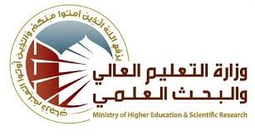

Flow up of implementation celli pass play

Hassan Ali Majeed |  |  |  |  | Course Instructor
hasanmajeed@uodiyala.edu.iq |  |  |  |  | E-mail
Seed technology |  |  |  |  | Title
weeks12 |  |  |  |  | Course Coordinator
Study of all types of seeds, their internal structures, seed vitality and strength, and the basic processes of seed germination |  |  |  |  | Course Objective
Defining seed technology, knowing the goals of seed technology, studying the parts of the flower, the processes of pollination and fertilization, the most important chemical components of seeds, parts of the seed, seed physiology, and seed latency. |  |  |  |  | Course Description
Seed technology book Jalal Hamid Hamza 2017 |  |  |  |  | Textbook
Final Exam | Project | Quizzes | Laboratory | Term Tests | Course Assessments
40% | 20% | 10% | 15% | 15%
Scientific visits |  |  |  |  | General Notes

University: Diyala
College: Agriculture
Department: : Field crops Sciences
Stage: three
Name: Hassan Ali Majeed
Academic Status:teacher
Qualification: Ph.D
Place of work: College of Agriculture

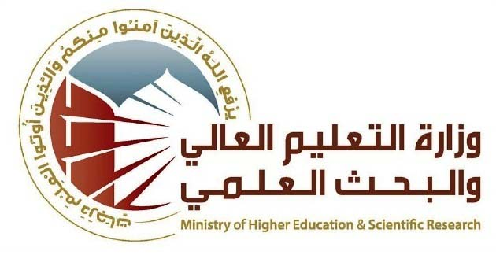
Republic of Iraq
The Ministry of Higher Education
& Scientific Research

Course Weekly Outline of
week | Data | Topics Covered | Practical Part
1 | 8/2/ 2024 | Basics of seed technology | Parts of the seed
2 | 15/2/2024 | Parts of a flower | Anatomy of the components of a flower
3 | 22/2/2024 | Seed components | Seed components
4 | 29/2/2024 | Seed physiology | Germination check
5 | 7/3/2024 | Seed activation | Germination speed
6 | Test 1
7 | 20/3/2024 | Piety | Study the necessary laboratory equipment
8 | 28/3/2024 | Field inspection | Drawing samples for models
9 | 4/4/2024 | Dicotyledonous seeds | Seed consignments
10 | 11/4/2024 | Growth regulators | Humidity check
11 | 18/4/2024 | Chemical components of seeds | Storage methods
12 | Second test
13 | 2/5/2024 | The phenomenon of multiple fetuses
14 | 9/5/2024 | Monocot seeds
15

Instructor Signature: Dean Signature:

