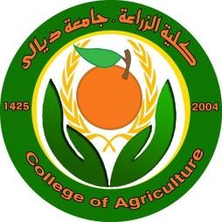
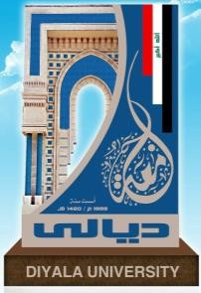
Ministry of Higher Education and Scientific Research _ Diyala University
College of Agriculture / Department of Animal Production
Curriculum Vitae of a faculty member

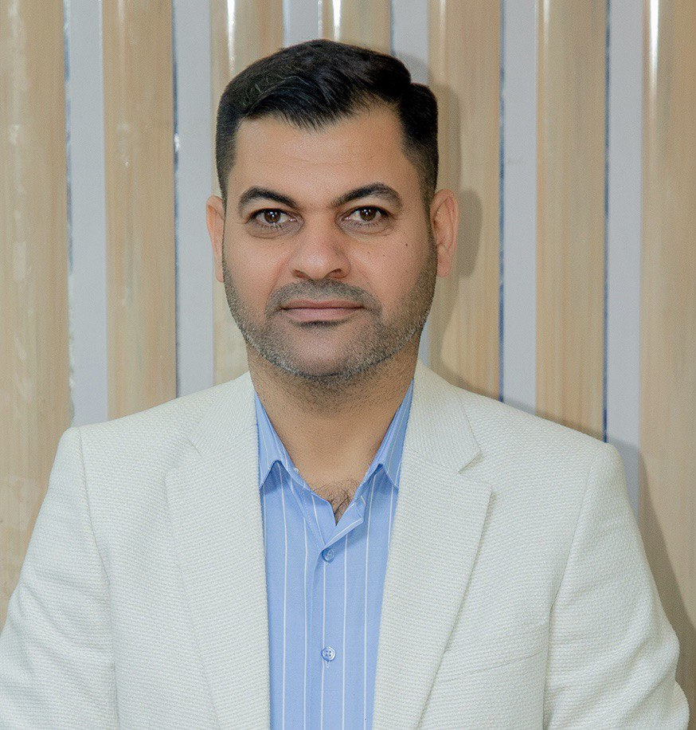

First: Personal Information

Full name | Nazar Sulaiman Ali AL-Zuhairy | Sex | male
Date of birth | 1979/7/26 | Marital status | married
Nationality | Iraqi | Email Address | nazaralzUhairy@uodiyala.edu.iq

Second: Academic degree

No | Academic degree | Date
1 | Master's degree in plant breeding | 2005
2 | PhD in plant breeding and genetics | 2014
3

Third: Master's and Doctoral Thesis

Title of Master Thesis | Estimation of genetic parameters in hybrids of yellow corn (Zea mays L.)
Title of PhD Thesis | Quantitative and molecular genetic analysis of single, triple, and double crosses of pure strains of yellow corn (Zea mays L.) and the possibility of quantitatively and molecularly predicting the yield of even crosses and its components.

Fourth: Scientific Activities

No. | Scientific Activities | Period
1 | Writing a book entitled (Guide to Laboratories in the College of Agriculture) | 2022
2

Fifth: Position Held

No. | The Administrative Tasks Assigned to You | Period
1 | Secretary of the College Council (College of Agriculture - University of Diyala) | 2014-2015
2 | Editorial Director of Diyala Journal of Agricultural Sciences (College of Agriculture - University of Diyala) | 2015-2016
3 | Assistant Dean for Scientific and Student Affairs (College of Agriculture - University of Diyala) | 2016-2019
4 | Assistant Dean for Administrative and Financial Affairs (College of Agriculture - University of Diyala) | 2020- Continuing to work
5

Sixth: Number of Committees in Which You Participated : ( More than 150 Committees )

The Most Important of which:

- Preparatory Committee for the First Scientific Conference for Agricultural Research, University of Diyala
- Statistical evaluation committee for theses and dissertations of postgraduate students at the College of Agriculture - University of Diyala
- Study Leave Committee inside Iraq at Diyala University
- Committee to study the reality of postgraduate studies at the University of Diyala
- Scientific Committee of the First International Scientific Conference for Agricultural Research, University of Diyala
- Committee for developing performance indicators for the strategic plan of the University of Diyala
- Committee for developing performance indicators for the strategic plan of the University of Diyala

Seventh: Curriculum Taught

No. | Subject/ Course Name | Stage
1 | Principles of statistics | First stage students
2 | Plant genetics | Third stage students
3 | Plant breeding | Fourth stage students
4 | molecular genetics | Master's and  PhD students
5 | Advanced experimental design and analysis | Master's students

Eighth: Supervision of Masters .

No. | Scientific Degree | Student's Name | Thesis's Title
1 | Masters | Yusif eabd alrahman mahmud | The effect of colchicine on the propagation and growth of the shlek plant in field conditions and in tissue culture
2 | Masters | Amna Muhammad Ali | Thermal collection of growth stages of yellow maize varieties and their relationship to yield and its components
3 | Masters | aisma' nafie badri | Molecular and quantitative genetic evaluation of pure introduced lines of cherry tomato under protected cultivation conditions
4

Ninth: Published and Accepted Researches:

- Estimation of some genetic parameters and field evaluation for pure lines of cherry tomato. Othman K Alwan , Nazar S Ali AL-Zuhairy , Asmaa N Badri. IOP Conf. Series: Earth and Environmental Science (2023).
- Study of variability at the molecular level between pure lines of Cherry Tomato. Nazar S. Ali AL-Zuhairy , Othman Khalid Alwan, Asmaa Nafea Badri. IOP Conf. Series: Earth and Environmental Science( 2023).

Tenth: Number of Training Courses: ( More than 20 Training Courses )

The Most Important of which:

- Applications of genetic engineering in the field of plant breeding
- PCR applications course
- Bioinformatics and Real-Time PCR applications course

Eleventh : Awards and honors :

- Thankful Documents from Minister of Higher Education &Scientific Research (More than 8)
- Thankful Documents from president of Diyala University (More than 20)

Thankful Documents from the Dean of College (More than 30).

