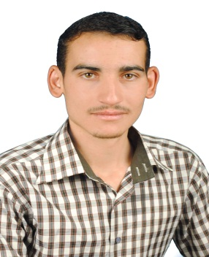
Othman Nassef Jassim Mohammed AL-Saedy
Address: Diyala/Iraq
Email: othmanjasim@uodiyala.edu.iq

Personal information :
Date and place of birth : 1990 Iraq .
Country –City : Iraq – Baquba .
EDUCATION :  Employment: | Bachelor Degree of Agricultural Sciences, Tikrit University  2012-2013 .  Master Degree in Agricultural Sciences, Tikrit University  2016 .  Lecturer at College of Agriculture, University of Diyala since 2017 .

Thanks and appreciation Awards: | Thanks and Appreciation letter from minister higher education 2021.  Thanks and Appreciation letter from minister higher education 2022.  Thanks and Appreciation letter from minister higher education 2023.  Thanks and Appreciation letter from chief Diyala university 2021.  Thanks and Appreciation letter from Dean of college Agriculture Diyala university .
Scientific research :
Estimating Genetic Parameters and Inbreeding Depression Effect of Diallel Crosses of Bread Wheat Genotypes ( Triticum aestivum L.) .

Effect of Planting Dates and Fertilizer Spraying (BRIX) on Growth and Yield Gharacteristics of Mungbean.
Certificates and conferences :
Certificate of participation in the first international virtual and fourth scientific conference for agricultural research at the College of Agriculture - University of Diyala, July 15-16, 2020.
Workshops, scientific seminars and seminars :
Fodder manufacturing and preservation (Hay) / 2023 .
Secondary metabolite compounds and antioxidants and their relationship to Nitrogen fertilizer / 2023 .
Introduction to agritourism / 2022 .

