Curriculum Vitae
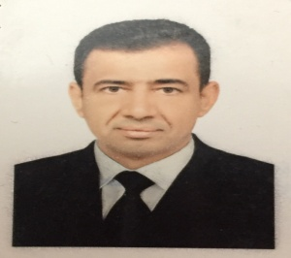 Name: Adnan Ghazi Salman
Official email : adnanghazi@uodiyala.edu.iq
Education :
PH.D. Agricultural Sciences : Horticulture and landscape Design -
Vegetable Production
University awarding the certificate : Baghdad
Academic degree : Lecturer
Bachelor of English Language : Baghdad university -

