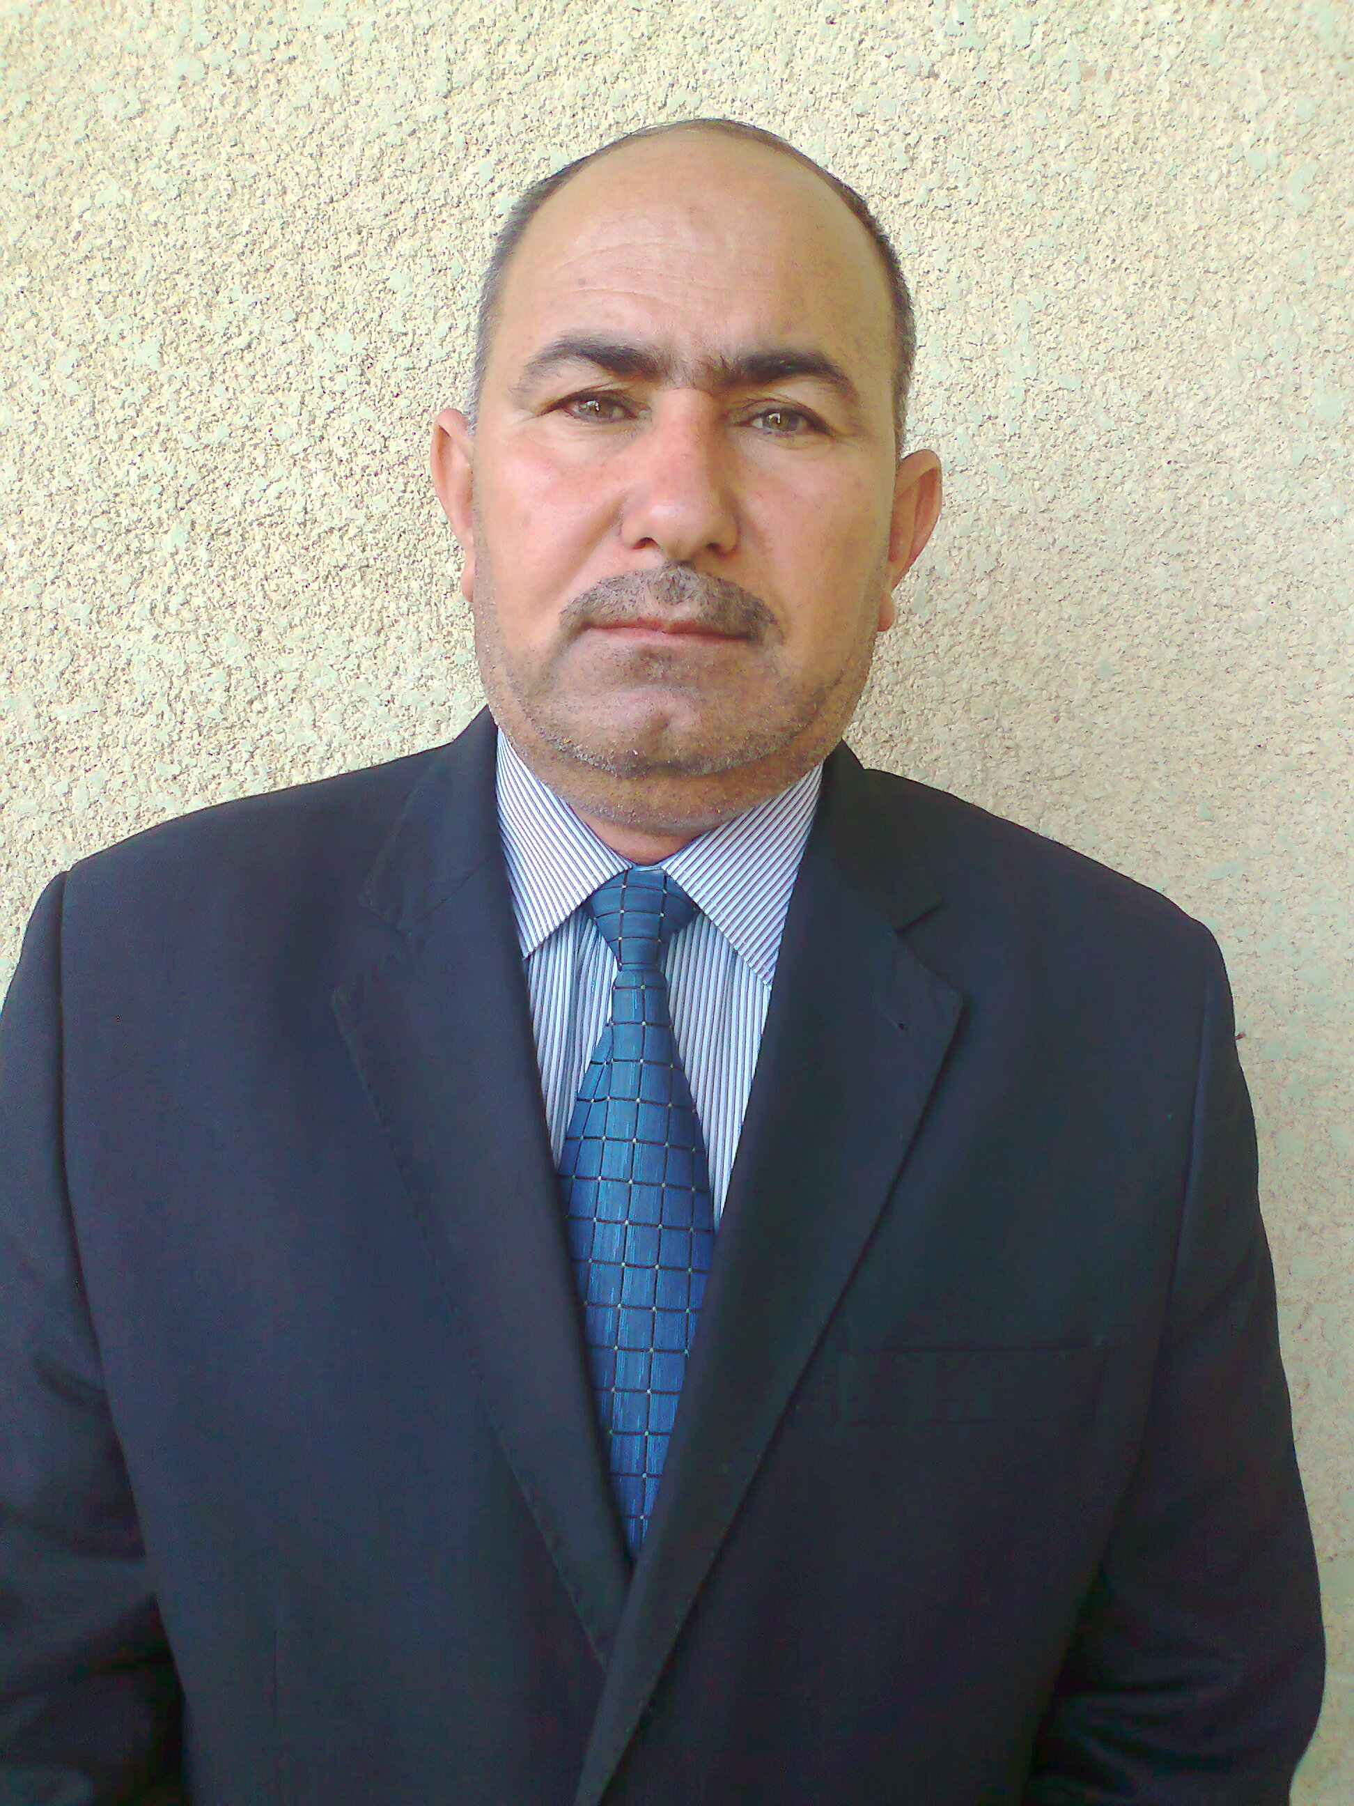
Dr. Faris Mohammed Suhail
Professor of soil microbiology
Education

1997-2000 Master.

Contact
[Your Address]
[Your Email]
Google scholar
Scoups

2001-2004 Ph.D.,

Work Experience

2003-2006 Assistant Lecturer at Baqubah Technical Institute
2006 Until now, Professor at the College of Agriculture / University of Diyala - Professor of soil microbiology

Presentations
- Scientific symposium - Chemical Pollution - Soil Department, College of Agriculture - Diyala - 25/4/2017.
- The Third International Scientific Conference on Agricultural Research - University of Kirkuk. College of Agriculture - University of Kirkuk 7-8/11/2018
- • The first virtual international scientific conference of the College of Agriculture - Diyala -2020
- Training course for trainers in the field of human development (TOT) - the General Union of Iraqi Trainers and the German Board for Training and Consulting-2020
- • Workshop on the dangers and toxicity of nanomaterials for the agro-ecosystem-2020
- • Production of vermicompost from earthworm-2021

Publications
- Biodegradation of Pesticides in Soil Amended with Different Organic Matters- Ecology-2020 .
- influence of Azotobacter chroococcum, Azospirillum brasilense, Trichoderma harzianum and Tri-calcium phosphate on hydroponically-grown barley grains-2nd Virtual International Scintific Agrticultural Conference- IOP Conf. Series: Earth and Environmental Science 735 (2021) 012056

Professional Memberships
• Member of the Soil Science Society
• Member of the American International Academy for Education and Training.
• Member of the Iraqi Innovation and Creativity Center (Inventors Forum)

Honors and Awards
- Letter of thanks number 3 from the Minister of Higher Education
- Thank you letter number 10 from the president of the university
- Thank you letter No. 20 from the Dean of the College
Other Skills

Use of Microsoft Word, Excel, PowerPoint

