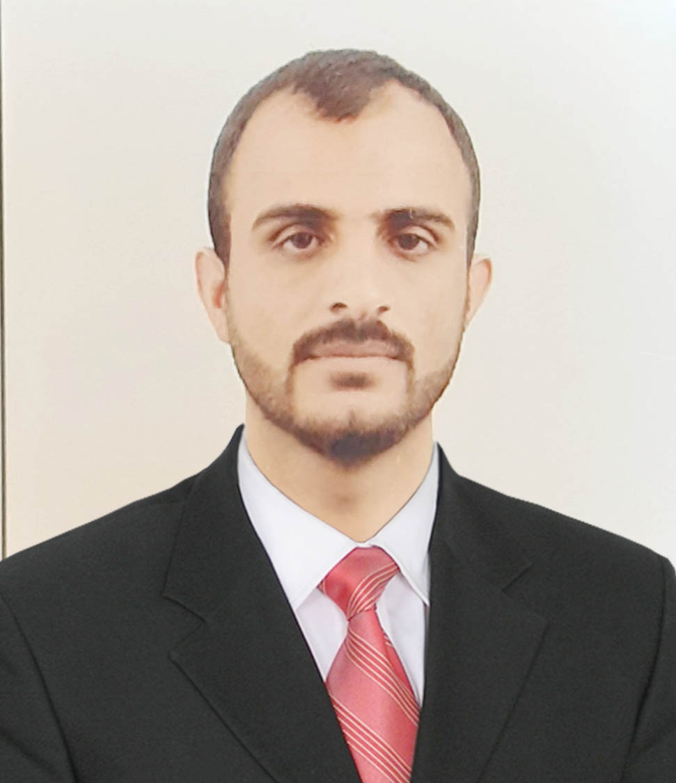

Assistant Lecturer Mohammed ail Shehab

**Education**

2020-2021 Master.

|  |
| --- |
| Contact |
| Baquba Diyala |
| mohamedshehab@uodiyala.edu.iq |
| Google scholar |
| Scoups |

**Work Experience**

2022 Assistant Lecturer at College of Agriculture - Diyala until now

**Presentations**

**Publications**

**Professional Memberships**

**Honors and Awards**

* Letter of thanks number 4 from the Minister of Higher Education
* Thank you letter number 2 from the president of the university
* Thank you letter No. 0 from the Dean of the College

**Other Skills**

Use of Microsoft Word, Excel, PowerPoint