Curriculum Vitae
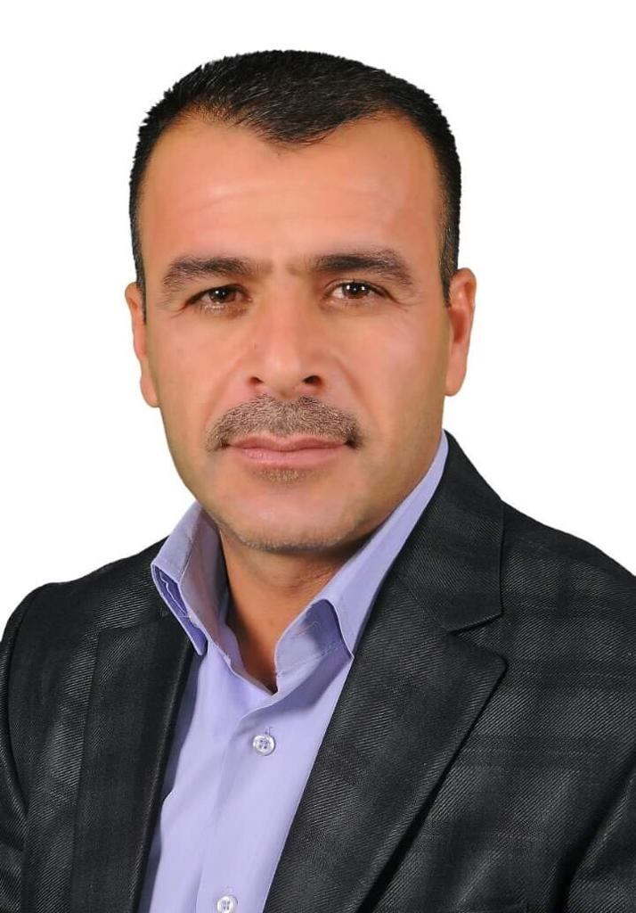

Omar Ali Ahmed Matter | Name
Ph. D from University putra Malaysia -2020 | Education
Physiology of Medicinal plant- Crop production | Expertise
https://scholar.google.com/citations?user=tZc2_U4AAAAJ&hl=en | Google Scholar
0096400000000000 | Mobile number
omerahmed@uodiyala.edu.iq | Email address

