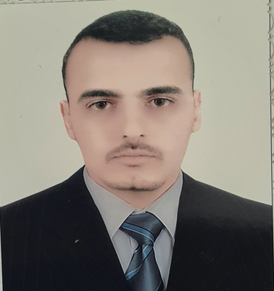
Personal Information:
Name | Nabeel Ibrahim Mohammed
Gender | Male
Date of Birth. | 25/07/1986
Place of Birth | 106,Kanaan -Baquba –Diyala Province -Iraq
Mobile: | +964 07717516273
Email: | nabeelmohammed@uodiyala.edu.iq  nabeelenv@gmail.com
Language Skills: | Arabic & English
Education
BSc in Agricultural Science/ Plant production.2009. College of Agriculture, University of Diyala. Iraq

M.Sc in Agriculture/ plant production (University of New England/Armidale /NSW2351/Australia

Employment
Assistant lecturer/ University of Diyala/Iraq
Experience
Worked for the Agricultural Extension and Training Directorate, Diyala-Iraq
Reward and Prizes: |  | Full scholarship for academic excellence sponsored by Gov. of Iraq to obtain Master Degree of Science Agriculture.

